Nga Iwi School
Bikes in Schools Project
Evaluation Report - DRAFT
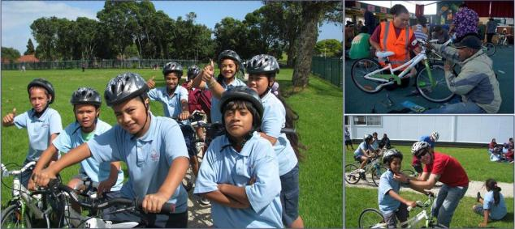

Prepared for Auckland Transport

by Mackie Research & Consulting Ltd
13 August 2012

Document Title: | Nga Iwi School Bikes in Schools Project
Prepared for: | Auckland Transport
Prepared by: | Hamish Mackie and Jo Gascoigne | Signed |  | Date
Reviewed by: |  | Signed |  | Date

Revision History
Revision No. | Amendments | Completed by | Date
Mackie Research and Consulting Limited (MaRC) is an organisation providing high quality independent human systems research and consultancy services. MaRC has expertise across a range of areas including transport human factors (road safety and sustainable transport), high performance, recreation, equipment design and evaluation and other areas where interactions between people and their environment or the things that people use are important.
Authorship: This document was written by Hamish Mackie and Jo Gascoigne. For further information, please contact Hamish using the contact details below
Disclaimer: MaRC Limited, its contributors and employees shall not be liable for any loss or damage sustained by any person relying on this report, whatever the cause of such loss or damage.
Mackie Research and Consulting Ltd
642 Great South Road
Ellerslie
Auckland
Ph 09 579 2328
MB 021 067 0337
www.mackieresearch.co.nz

Table of Contents

1 Introduction 5

1.1 Purpose 5

1.2 Background 5

1.3 Ngw Iwi Bikes in Schools Goal, Objectives & Scope 6

2 Evaluation approach 7

2.1 Process Evaluation 7

2.2 Outcome Evaluation 8

3 Nga Iwi Cycle Project Implementation and Operation 11

3.1 Planning and funding 11

3.2 Organisational Support 11

3.3 Design 12

3.4 Track Construction 13

3.5 Purchasing bikes and helmets 13

3.6 Constraints 14

3.7 Opening Day 14

3.8 Training 15

3.9 Activity Diary 17

3.10 Current cycle track use at Nga Iwi School 18

4 Process Evaluation Findings 19

4.1 Selection Criteria 19

4.2 Project organisation and planning 19

4.3 Funding 20

4.4 Track design & construction 20

4.5 Bikes & Equipment 20

4.6 Training 20

4.7 Summary of the process evaluation 20

5 Outcome Evaluation Findings 23

5.1 Focus Groups 23

5.2 Cycle counts and bike rack counts 25

5.3 Pre-Training Surveys 27

6 Specific considerations & recommendations 28

6.1 The implementation process 28

6.2 Project outcomes 29

6.3 Longer-term considerations – more people cycling in Mangere more often? 30

7 Final comments 32

Appendices
- Full activity diary – Auckland Transport Project Manager, Rebecca Hayden
- Focus group questions
- Pre cycle training surveys

Highlights
- The Nga Iwi School Bikes in Schools project was effectively implemented thanks to significant support from businesses, community grants and government organisations, including project management from Auckland Transport
- The cycle track, bikes and cycle training are all well used, six months following the project opening.
- The Nga Iwi School community is very grateful for the facilities. Parents and teachers already see a range of benefits including improved student health, confidence, school attendance and pride in their school.
- Within the scope of the Bikes in Schools aim, the project has clearly been a success.
- Achieving the broader and longer-term goal of more people cycling in Mangere remains to be seen. However, a number of enablers such as access to affordable bikes, user-friendly cycling infrastructure, on-road cycle training and sport cycling opportunities will likely be required if a widespread culture of cycling in Mangere is to develop.

Executive Summary
In 2011, Auckland Transport investigated the possibility of introducing the ‘Bikes in Schools’ initiative at Nga Iwi School in Auckland. The inspiration originated from Paul McArdle’s, Bike On ‘Bikes in Schools’ initiative where a number of school projects in Hawke’s Bay have been successfully implemented.
Auckland Transport identified Nga Iwi School as an ideal candidate to receive the pilot project for Auckland based on low levels of cycling in the area. A previous school travel survey for Nga Iwi School showed that there is a desire to change the current cycling situation. It was then considered that the Bikes in Schools approach might be a way to stimulate a cycling culture in the School and the wider community.
The Nga Iwi School project aimed to provide all primary school children with access to a bike, helmet and facilities to enable them to learn how to ride a bike in a safe environment.
The purpose of this report is to evaluate the process of implementation and the outcomes the project has produced. Methods used to evaluate the project implementation included regular conversations with the Auckland Transport project manager, visiting the project opening day, gathering information, an activity diary completed by the Project Manger and focus groups. The focus groups were also used to evaluate the immediate outcomes of the project and case studies were also compiled for this purpose. Neighbourhood cycle count surveys, bike rack counts and pre cycle training surveys were used to gather baseline data that can be used for a longer-term quantitative evaluation of cycling development in Mangere, in the future. The baseline data does reinforce that cycling levels in Mangere were particularly low at the beginning of this project.
The project commenced in March 2011, managed by Auckland Transport in close partnership with the school. Following commitment from the school, a number of local businesses donated their products and/or services to build the track, subsidise bikes and provide support. Cycle training was then provided for students and teachers, which is currently on-going.
The project was implemented successfully and the cycle track was officially opened on 1st March 2012 by the Mayor of Auckland Len Brown. Grade 1 training was provided to all Years 5 and 6 students as well as teachers, who would be supervising the riding on a daily basis. The facilities included a 280m bike track, 20x20m pump track, 20x20m skills track, 30 new bikes and a supply of new helmets.
Overall, the project was implemented very effectively, in large part due to a very determined effort by the Auckland Transport Project Manager. Good use of the knowledge gained from the previous Bikes in Schools projects was made through regular contact with Paul McArdle. A result of this partnership has been the development of a document that outlines all the necessary considerations for a Bikes in Schools projects. The project has relied heavily on receiving community support, funding and sponsorship. The ability to reproduce this level of community interest for future projects is an important consideration.
Focus groups conducted with parents, teachers and students two months following the opening of the track found the following key themes:
- The project was well planned with good communication and coordination
- The track was well designed.
- There is an overwhelming sense of pride towards the project. All groups felt privileged and proud that their school was chosen.
- A lot of new information was learnt at the bike training sessions and workshops.
- The project has perceived health, confidence and various other benefits for students.
- Cycling is fun. Great to see so many happy children.
- Some children now see cycling as a sport option.
- Students would like to cycle to school and parents and teachers suggested further road riding training for students.
- The cost to purchase a bike is a considerable constraint – some students don’t even own closed shoes, which are required to use the bikes. This emphasises the level of financial deprivation being experienced by some families.
- There is some concern about long term maintenance of the project.
- Parents and teachers would like to see the bike track and facilities maximised by opening the facility before and after school and on weekends and consider the possibility of hiring bikes to the community on weekends and during school holidays.
A number of considerations and recommendations are made, following the findings of the evaluation:
- Ensure that the track design specifications and quality are maintained for future projects
- Establish links with charities, trusts and local businesses that can provide financial assistance or sponsorship. The project currently relies heavily on this type of funding
- Prepare a maintenance plan for the bike track, bikes and equipment and establish an annual budget for maintaining the facilities and equipment.
- The cycle training and workshops were an essential part of the project as students, teachers and parents reported how little they knew about cycling prior to the project
- Teacher training is essential if they are to continue teaching the necessary bike skills and supporting students during biking activities.
- In order to keep interest in the facilities alive, regular promotion of the facilities in newsletters, website etc might be helpful. Perhaps organise a series of cycle events throughout the year for example during Bike Wise Month (February). However, there is currently no problem with waning interest in the facilities. A very recent discussion with the school revealed that interest is as strong as ever, six months following the opening of the track.
- Establish Grade 2 Training for Year 6 students. However, the evaluators would add that in parallel with encouraging students to cycle to school, road safety measures must be implemented in parallel with training to create a safe and user-friendly cycling environment for young school students. This may include identifying safe routes to school, traffic calming and engineering specific cycling facilities.
- Consider maximising the use of the school bike track facilities by allowing track use by students before and after school and possibly in weekends.
- Consider setting up a bike hire system to student’s families to use bikes on weekends and during school holidays.
The Nga Iwi Bikes in Schools project has clearly achieved its aim and represents an excellent start in sparking a culture of cycling in Mangere – the ultimate goal of this project. However, it is clear that in order for this goal to be realised there are a number of further areas that need to be addressed in order to successfully lever off this initiative. Future cycling in Mangere could take the form of school and workplace commuting, recreational cycling, utility cycling (e.g. to shops and other short trips) or sport cycling. These different types of cycling have different requirements, which will need to be met (shown below), in order to increase numbers in the different areas.
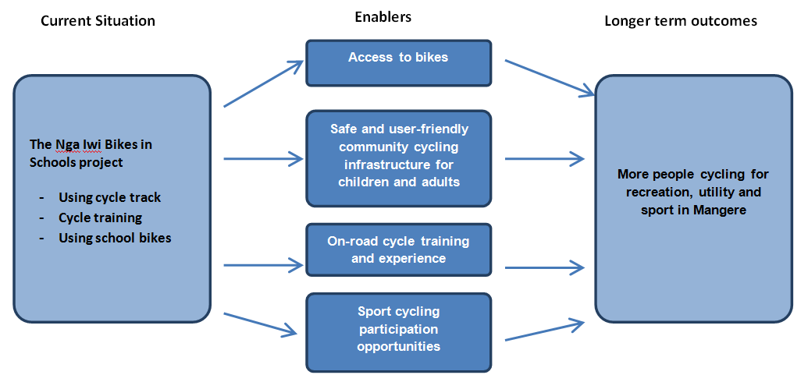

It will be critical that the owners of these enablers play their part to lever off this very worthy initiative, to eventually create a true culture of cycling in Mangere.

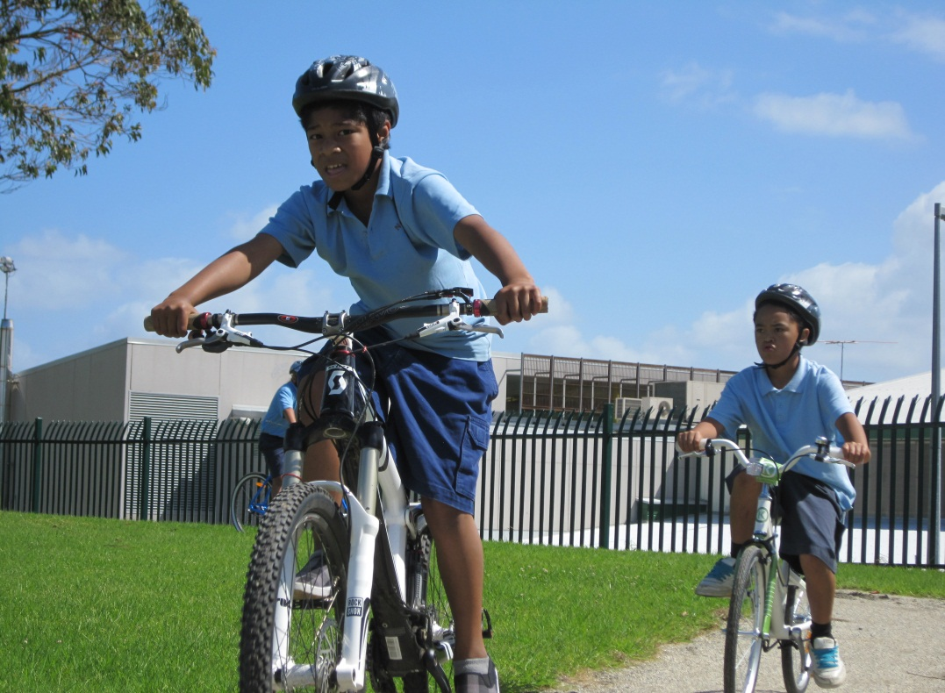

Project sponsors and key supporters
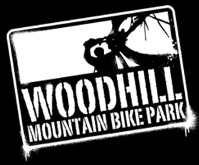
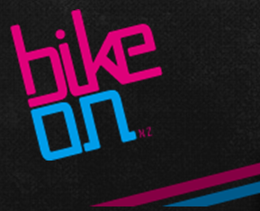

Introduction

Purpose
The purpose of this report is to evaluate the Nga Iwi School Bikes in Schools project. This includes documenting and commenting on the implementation of the project, investigating the immediate outputs and outcomes from the project and discussing considerations and recommendations for Nga Iwi School and other related future projects.

Background
In 2011, Auckland Transport investigated the possibility of introducing the ‘Bikes in Schools’ initiative at a school in Auckland. The inspiration for this project originated from Paul McArdle’s, ‘Bikes in Schools’ initiative where a number of projects in Hawkes Bay were successfully implemented. The first project was implemented at St Mary’s School in Hastings, Hawke’s Bay in February 2010. It was coordinated and partly funded by ‘Bike On NZ’, a not-for-profit organisation founded by Paul McArdle and Meg Frater in November 2009. The project aimed to provide all primary school children access to a bike, helmet and facilities to enable them to learn how to ride a bike in a safe environment. St Mary’s School were provided with 62 new bikes, 225 helmets, a dedicated staff resource, a 550m cycle track, two pump tracks, a skills track and a bike shed. Since February 2010, over 1000 Hawke’s Bay school children have been given the opportunity to learn to ride bikes on a regular basis within school grounds. Bike On’s initiative aims to;
‘… encourage primary school pupils to become more active and healthy, help them develop various bike skills, build their self-esteem and confidence, all while in a safe and familiar environment.’

Why Nga Iwi School, Mangere?
Nga Iwi School is a co-ed primary school with a roll of over 400 students, the majority of whom come from a Maori or Pacific background. The school is located on Mascot Avenue in Mangere, Auckland situated south-east of the Mangere Town Centre (Figure 1).
Auckland Transport identified Nga Iwi School as an ideal candidate to receive the pilot project for the Bikes in Schools initiative based on the low cycling statistics for the area. A baseline survey of Nga Iwi School students and parents in 2010 as part of a School Travel Plan identified that no students were cycling to school. As part of the survey students were asked to identify their preferred method of travel to and from school. Fifteen per cent of students surveyed indicated that they would like to either cycle or scooter to school.
The completed school travel plan reflected the school community’s desire to change the current cycling situation at Nga Iwi School. It was considered that the Bikes in Schools approach might stimulate a cycling culture at Nga Iwi School and hopefully also the wider Mangere community. In addition to this, Mangere is currently working towards a World Health Organisation (W.H.O) International Safe Community Accreditation which includes achieving goals in child injury prevention and general road safety. At present, Nga Iwi School is a Travel Wise school and has 3 Walking School Buses operating. The school and surrounding community have strongly supported the Travel Wise programme and believe that the Bikes in Schools project would strongly support their existing Travel Wise initiatives.

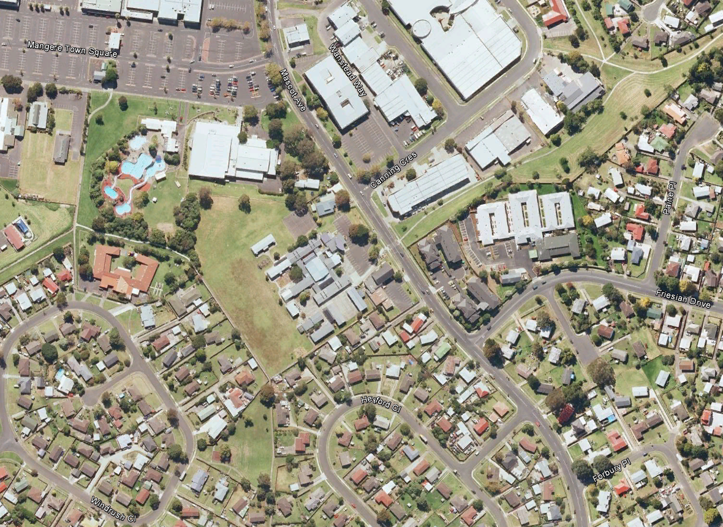
Nga Iwi School
Figure 1. Aerial View of Nga Iwi School and surrounding neighbourhood

Ngw Iwi Bikes in Schools goal, objectives & scope
The goal of the Nga Iwi Bikes in Schools project (called “the project” hereonin) was to create opportunities for Nga Iwi students to learn to cycle and experience cycling in a safe environment by building a cycle track within the school grounds, providing bikes and creating a regular cycle safety training programme for students. Below are the objectives of the project:
- Provide facilities and appropriate equipment for students to learn how to ride bikes;
- Provide a safe learning environment; and
- Provide the appropriate training for students to learn how to ride bikes confidently.
The following potential outcomes from the project were also identified:
- Student’s skills and safety levels are increased leading to increased and on-going cycling participation;
- Increase physical activity and improved health in school students;
- Cognitive benefits from increased exercise; and
- Through the creation of opportunities for students to cycle and use the track during school hours, this will create enthusiasm among parents and caregivers to explore other recreational cycling areas together as a family outside of school hours. It is hoped that this will in turn improve the health and wellbeing of the whole family.
A long term goal of the Nga Iwi School cycling project is to reduce the number of car trips to and from school by encouraging cycling as a viable mode of commuting to and from school (hence project leadership from Auckland Transport). However, it is understood that a number of other system components may need to be in place before this happens, such as on-road cycle training and the identification of cycle routes to school and any associated traffic calming that may be needed.

Evaluation approach
Evaluating the Nga Iwi School Bikes in Schools project is important as it provides documentation of the project’s activities, identifies successes and challenges of the project, and will eventually quantify outcomes from the project. This can then be used to make recommendations for any on-going activities that may follow at the school and elsewhere, and help justify further initiatives.
Two types of evaluation were carried out, process and outcome evaluation. Process evaluation is concerned with what was implemented and outcome evaluation focuses on the changes that happened after the project was implemented.
A logic model can be a useful way to show the rationale for a project and the evaluation stages that relate to the project. Figure 2 shows the logic model that was developed for the Nga Iwi cycling project at the beginning of the evaluation, including the process of implementation and expected outputs and outcomes.

Process Evaluation
The components (inputs and outputs) of the project were evaluated in order to document and assess how well the project was implemented i.e. how well the bike track, bikes and training were implemented and to determine any issues that arose and what might be improved for next time.
The first stage of the Nga Iwi School Cycling project involved the construction of the track, sourcing bikes, setting up storage and implementing training. Because this is a relatively new concept for Auckland and may involve a number of challenges, it is logical that the major focus of this evaluation is on the process of establishing the project, as opposed to the outcomes that will take time to materialise.

Process Evaluation Measures

Information Gathering
Information about the process of implementing and developing the project was collected through conversations and other material passed on by the Auckland Transport project manager. The evaluator attended the opening day for the project and spoke with various project members and school staff to gain further insights into the project and how it had been implemented.

Activity Diary
An activity diary was used by the project manager to record issues and achievements for the implementation of the project. A summary of the activity diary is included in Section 3.9 and the full activity diary is included in Appendix A.

Focus Groups (Process)
Three separate focus groups were carried out with students, parents and teachers to capture their feedback on the project. The focus groups were carried out by a facilitator (the evaluator) asking a series of questions, based on a previously agreed question structure, and encouraging participants to answer freely when they wanted to contribute. The discussion included questions about the implementation process including the planning, design and construction of the bike tracks, purchasing bikes and equipment and the provision of training. The key themes from all the focus groups is included in Section 5.1 and the questions that were used for the focus groups are given in Appendix B.

Outcome Evaluation
Ideally, outcome evaluation involves assessing the short, medium and long-term outcomes of a project to determine how effective the programme has been i.e. what effects did the bike track, bikes and training have on Nga Iwi School and community cycling? However, longer-term outcome measures (change in cycling behaviour) are likely to occur over time, as the project has time to influence behaviour within the community and are therefore outside the scope of this evaluation. Nevertheless, a data collection framework and baseline data for cycling in the community has been established so that the measures can be repeated in the future to determine a change in cycling activity.
Short-term outcomes are more immediately measurable following implementation, and is the focus of this evaluation. The following section summarises the baseline measures for longer-term outcomes as well as shorter-term outcomes measures used to evaluate the outcomes of this project.

Outcome Evaluation Measures

Baseline Cycle Counts
Baseline manual cycle count surveys were undertaken to identify the current levels of cycling in the Nga Iwi-Mangere community. They were carried out at the following three major intersections in close proximity to Nga Iwi school:
- Mascot Avenue – Fresian Drive
- Mascot Avenue – Massey Road
- Mascot Avenue – Bader Drive
At each location and on different days, the cycle count surveys were carried out for two weekdays and two weekend days. The average of the two counts for each location and day type are presented in Table 3. For weekdays, counts were carried out between 6:30am and 9:00am and between 3:00pm and 6:00pm. For weekends, the counts were carried out between 10:00am and 3:00pm (with a 1 hour break at mid-day). Cycle counts were broken down by child/adult, road/path and movement direction within the intersection. The results of these surveys are summarised in Section 5.2.1.

School Bike Rack Counts
School bike rack counts were carried out at four schools in Mangere over three days to determine the number students cycling to and from school. The counts were carried out at:
- Nga Iwi School
- Jean Batten School
- Mangere Central School
- Sir Douglas Bader Intermediate School
The bike rack counts aimed to determine the current level of students cycling to and from school as another way of measuring cycle activity of school aged children within the Mangere community. The results of these surveys are summarised in Section 5.2.2.

Pre Cycle Training Surveys
Pre cycle training surveys of all students who received cycle training prior to project implementation were carried out. This provided information on the level of bike use by students and reasons for or against riding a bike. The results of these surveys are summarised in Section 5.3 and included in Appendix C.

Focus Groups (Outcome)
As mentioned in 2.1.1iii, three group interviews were carried out with students, parents and teachers to capture their feedback on the project. The interview also included questions about the outcomes from the track development and equipment supplied. The key themes from all the focus groups is included in Section 5.1.

Case Studies
Two individuals from Nga Iwi families who had interesting stories to share related to the Nga Iwi project were interviewed. Their stories are included later in the report.
Figure 2 Logic Model for Nga Iwi School Bikes in Schools Evaluation
Why this project?
- Strong school community support
- Low levels of cycling in low socioeconomic communities
People
Funding
Time
Materials
Infrastructure /
Activities
Track
Bikes (and Storage)
Training
Short-term Students cycling for fun in neighbourhood
Medium-term Students cycling to school
Long-term Children and parents commuting and cycling for health
Participation
Cycling on track
Training participation

Long-term goal:
More people cycling in Mangere more often
Initial Evaluation Activity
Why did the programme happen?
What happened?
How did it happen?
Who did it?
How effective was it?
What might be the outcomes?
Nov 2011
July 2012

z

Nga Iwi Bikes in Schools project Implementation and operation

Planning and funding
Once the school agreed to take part in the project, the planning phase began by setting up a suitable staffing structure and finding the necessary resources to implement the project.

Project funding
Funding the track and the bikes was deemed to be outside the scope of Auckland Transport’s funding responsibilities and hence there was a need to secure funding for these crucial parts of the project. Various funding options were explored and secured with several local businesses and organisations offering to donate their products and/or services as a form of sponsorship. This support included:
- Auckland Transport provided a Project manager to oversee the delivery, and secure funding for the project. They also assisted in organising cycle training to all Year 5 and 6 students;
- John Fillmore Construction donated equipment and staff time to build the main track free of charge;
- Winstone Aggregates donated over 40 tonnes of limestone for the track surface;
- Woodhill Mountain Bike Park designed the pump and skills tracks at a discounted rate;
- Adventure Brands offered discounted bikes to be purchased by the school and offered a free workshop for parents to assemble the bikes and learn how to maintain them.
Where specific aspects of the project were unable to be sponsored, applications for funding with two charities were lodged, both of which were successful, including:
- a $10,000 donation from Counties-Manukau Sport to build the pump and skills track;
- a $7,500 grant from the Lion Foundation to purchase bikes and equipment.
The estimated cost, including sponsorship and in-kind works, to construct the bike track facilities and supply bikes and associated equipment was approximately $70,000.
A summary of the activity diary, kept by the Auckland Transport Project Manager, documented the planning process and has been included in Appendix A.

Project Management
Two project managers were appointed to manage the project. The school appointed their own Project Manager, David Bowes, as a requirement by the Ministry of Education to oversee the project from the school’s perspective. David Bowes liaised with Auckland Transport’s Project Manager Rebecca Hayden throughout the project. Figure 3 outlines the parties involved from the planning phase through to implementation. Communication between all parties was paramount to ensure the project was implemented successfully.

Organisational Support
The following organisations supported the project:
- Auckland Transport
- Ministry of Education;
- Cycle Action Auckland;
- Bike NZ;
- Bike On – Paul McArdle; and
- Nga Iwi School Board of Trustees.

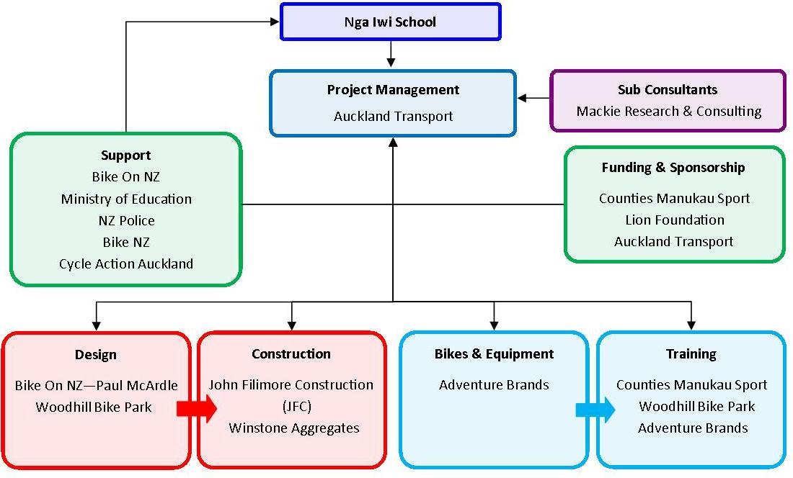
Figure 3 - Project Team Structure NEEDS A FEW CHANGES

Design
The Auckland Transport Project Manager approached Paul McArdle from Bike On NZ to assist with the track design. The original Bikes in Schools projects in Hawke’s Bay did not have documented plans for their implementation, and so it was agreed that documentation of the designs and specifications for Bikes in Schools projects were essential to ensure that the on-going quality of future projects is maintained. Bike On has since developed a guide to implementing bike tracks. The guide provides, among other information, track dimension specifications, slopes and drainage required, how the track is built, what materials are used and what quantities are required.
The skills track was designed and built by Mark Harrrowfield and the pump track by Haydn Shore from the Woodhill Mountain Bike Park in West Auckland. Mark has been involved in bike track design and construction for over 11 years and Haydn for 8 years and so a wealth of bike track design experience was bought to the project.

Track Construction
Construction commenced in January 2012 and it took three days to carve out the new 280 metre long track (Figure 4). Over 40 tonnes of limestone was used as a top coat for the track. The earth cut out from the main track was used as fill on the pump and skills track (Figure 4). Slalom poles, bridges, berms and see-saws were all constructed as part of the skills track (Figure 6).
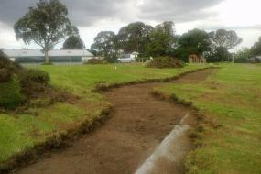
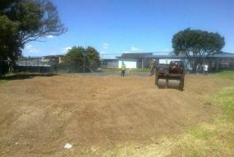
Figure 4 - Construction of the main track (left) and pump track (right)

Purchasing bikes and helmets
Bikes were purchased from Adventure Brands. Correctly sized bikes were chosen from the Byk range (Figure 5) as they are ergonomically designed for children and are of good quality.

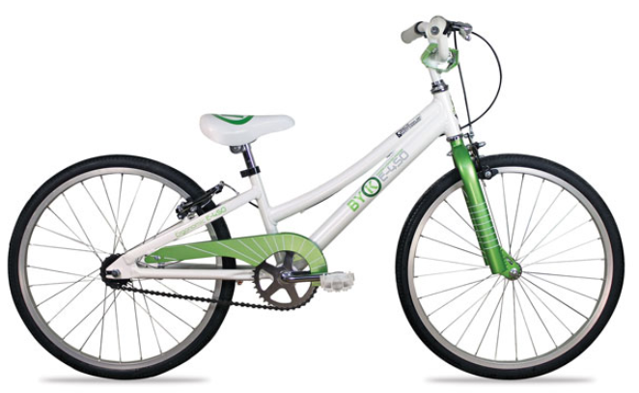
Figure 5. Example of bikes that were purchased for the Nga Iwi project

Constraints

Funding Limitations
Funding for bikes was limited to purchasing only 30 bikes instead of the initially requested 60 bikes. As a result of this funding shortage, the school made the decision to purchase bikes suitable for senior students (years 5 and 6) and to investigate purchasing smaller bikes for the juniors at a later date.

Bike Storage
Storage for the bikes was an initial concern as the school were unable to build a new storage facility as it would a require resource consent which could potentially delay the project. The school resolved the issue by shifting property out of an existing garage on school grounds and using this for storage.

Opening Day
On 1st March 2012, the Nga Iwi School cycling track and facilities were officially opened (Figure 7) by the Mayor of Auckland Len Brown. The facilities included:
- a 280 metre winding limestone track.
- a 20 x 20 metre pump track consisting of humps to ride over.
- a 20 x 20 metre skills track consisting of berms, bridges, see-saws and slalom posts.
- 30 new bikes of various sizes
- X helmets of various sizes
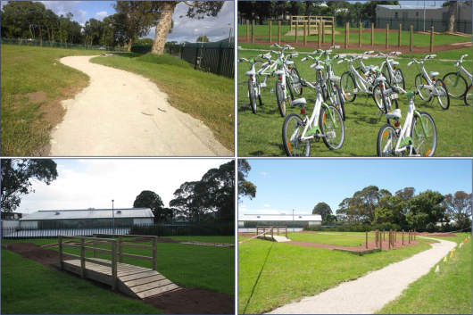
Figure 6 - Completed Main Bike Track (top left), Bikes (top right) and Skills Track (bottom left and right)
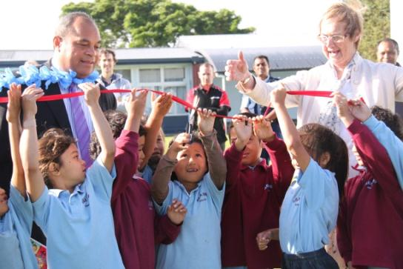
Figure 7 - Opening Day - Nga Iwi Students cut the ribbon
Following the official opening, the school enjoyed a cycle fun day which included all 400+ students who participated in cycle activities held throughout the day.

Training

Student’s Grade 1 training
Following the opening, cycle training was provided to students in April, by Big Foot, in accordance with the NZ Transport Agency’s (NZTA) Cyclists Skills Training Guidelines, March 2012 (www.nzta.govt.nz/resources/cyclist-skills-training-guide). All students involved in the project were trained to Grade 1 level. This involved teaching children from Year 4 onwards (8+ years old) to ride a bike in a non-traffic environment. The training also included:
- Completing a bike and helmet check;
- Understanding the legal requirements and safety equipment for bicycles;
- Basic bike skills – mounting, start, stop, steering;
- Signalling; and
- Using gears.
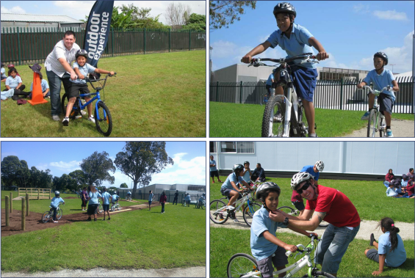
Figure 8 - Cycle Fun Day & Training

Teachers Training
Teacher training was also provided so that they could effectively supervise and provide guidance for the students riding on the track. Apart from the practical requirements for assisting students on the track, the teacher training included information about the legal requirements for riding a bike on the road (although road riding was not covered as part of this project).

Parents Workshop
Parents were invited to join a workshop to initially build the bikes, but also learn basic maintenance skills (Figure 9).
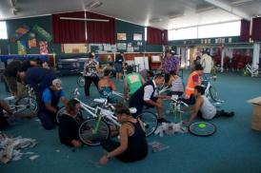
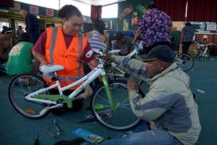
Figure 9 - Bike Workshop – Parents take part in assembling the bikes

Activity Diary
An activity diary was kept by the Auckland Transport Project Manager throughout the life of the project from March 2011 to May 2012. The diary identified a number of achievements and issues faced during implementation. Table 1 shows a summary of the achievements and issues faced. The full activity diary has been included in Appendix A.
Table 1 - Activity Diary Timeline Summary
Timeline | Achievements | Issues
March 2011 | - Nga Iwi School agreed to be part of the Bikes In School project.
July 2011 | - Auckland Transport appoints a Project Manager, Rebecca Hayden. | - No design or construction plans available from Bike On NZ’s pilot project in Hawke’s Bay. May have to design tracks from scratch.
August 2011 | - Project plan for Mangere Community Cycling Project | - Problem with finding storage for bikes. No additional funding available to build.
 | - School find storage for bikes using a garage on-site.
October 2011 | - Project plan signed off by MoE.  - School appoint a Project Manager, David Bowes to act on behalf of the school.
November 2011 | - JFC Construction agrees to build track free of charge.  - Woodhill Bike Park owners agree to design/build pump/skills track but unable to design/implement free of charge.  - Bike On NZ provide bike track designs and specifications for construction. | - Need to find $10,000 to fund pumps/skills track.
December 2011 | - Mayor has confirmed he will attend Opening Day on 1st March 2012.  - Lion Foundation approves funding for 30 bikes and helmets. ($7,500)  - Winstone Aggregates agree to supply limestone for tracks free of charge.  - Counties Manukau Sport approves funding to build pump/skills track $10,000.
January 2012 | - Bike track construction begins. | - Insufficient limestone provided to lay on all bike tracks. Red rock purchased as a substitute as was a cheaper option.
 | - Track construction completed before school returns for Term 1.
February 2012 | - Bike building workshop held with 15 parents attending to help. Adventure Brands assisted in preparing bikes.
March 2012 | - Opening Ceremony held 1st March followed by a Cycle Fun Day for the whole school. | - Red rock is considered too thick and bike wheels are getting stuck. May need to replace with limestone.
 | - Removal of some of the red rock has improved riding surface and is packing down well.
April 2012 | - Bike training commences for Year 5 & 6.
April-May 2012 | - Woodhill Mountain Bike Park commence intensive bike and track training for students and teachers.
May 2012 | - Interviews with focus groups (students, teachers, parents) are undertaken as part of project evaluation.

Current cycle track use at Nga Iwi School
The following arrangements are currently in place for the use of the bikes and cycle track:
- Counties Manukau Sport provides cycle skills training, using the bikes and cycle track, three times per week, with junior and senior students being taught separately
- Teachers also supervise pre-arranged bike track use (junior and senior students separately) during morning tea (40 minutes) and lunch times (40 minutes).
- During PE sessions every Thursday
The bikes and track at Nga Iwi School are used every school day.

Process Evaluation Findings
Evaluating the processes undertaken to deliver the Nga Iwi Bikes in schools project (along with immediate outputs) provides valuable lessons for future cycle projects. The focus for the process evaluation is on the any gaps between what was intended to be delivered and what was actually delivered.

Selection Criteria
The school was considered an ideal candidate for the first Bikes in Schools project to be implemented in Auckland due to the low cycling statistics taken from recent surveys undertaken by Auckland Transport. Establishing criteria for eligible schools for future projects may be required where several schools may have similar low cycling statistics. Selection factors may include the commitment demonstrated by the school and surrounding community, potential supplementary funding from local organisations or sponsors and need demonstrated by local cycling data and other sources.
Socio-economic status or level of social deprivation is also an important consideration. Increased cycling in higher deprivation areas has the potential to yield greater benefits compared with more affluent communities, through improved health and access to employment and social opportunities in particular.

Project organisation and planning
The activity diary and conversations with the project team suggest that the Nga Iwi project benefitted from a highly driven team to deliver a quality project for the Nga Iwi school community. In addition to the clear support and enthusiasm from Nga Iwi school representatives, the Auckland Transport Project Manager, in particular, was key to ensuring the success of the project.
Good communication was a key component in the success of the project. Parties involved were well informed and kept up to date. Coordination of construction activities assisted in reducing project costs (e.g. using the cut material from the main bike track on the pump track and coordinating the construction of both tracks at the same time to minimise machinery hire). Maximising resources available further reduced costs (e.g. use of an old garage on-site to store bikes instead of building a new shed). Documenting the design and specifications of the bike tracks for future reference was essential and a step forward for the wider Bikes in Schools initiatives.
The project team made good use of existing knowledge and resources to implement this project. Bike On Director Paul McArdle was contacted for guidance very early in the project, and this communication was maintained, which helped significantly. Local businesses were approached to assist in the design and construction of the three different tracks. The team identified suitable funding opportunities for the project, which was vital for the progression and success of the project.
One area of the project that might have been better managed was possibly the over-reliance on the Auckland Transport Project Manager in delivering the project. The scope of responsibilities for this role appeared to be wide-ranging and unclear for the project, and the role could have benefited from more formal leadership, perhaps by way of a project steering group. The sheer determination of this person was a large factor in the success of the project.

Funding
Receiving sponsorship and funding from local businesses and charities was vital to the success of this project. Local businesses received good publicity from this pilot project but continuing this level of support may not be feasible for all businesses. While funding for this project came together following some persistent efforts, a clear funding model, established at the beginning, would be useful for subsequent projects. The benefits that eventually come from the Nga Iwi project could provide an indicator of the organisations that may have an interest in supporting such projects in the future.

Track design & construction
The design and construction of the track generally ran smoothly and the project team were able to secure the expertise and labour required to the build the tracks to a good standard within a reasonable timeframe. One issue related to the quality of the track was its width. The track averages approximately 1.2m whereas a width of 2m is suggested as ideal. No doubt funding limitations had a role to play, and by all accounts the track does still work well. However, overall, a more usable track may have been realised if the track had been built to the specified width. At times there were also minor issues such as aggregate type and amounts not quite matching what was intended, but these issues are relatively minor and have all been resolved.

Bikes & Equipment
The bikes and helmets have proven to be very suitable for the school. The only limitation was that 30 bikes were purchased instead of the recommended 60, due to funding constraints. To date there have been no reports of excessive maintenance issues or theft. There may have been some issues related to the relative number of smaller and larger bikes, but this would have been very difficult to accurately match with demand.
The bike assembly workshops didn’t quite run to plan, although it was still a very useful exercise to engage the school community with the project. Such future workshops might need more structure, to reap the full benefits of such activities. However, it does need to be acknowledged that the workshops were provided free of charge, so any real criticism is unwarranted.

Training
Grade 1 training was well received amongst students and teachers and feedback from focus groups indicated that the trainer/s did a good job, showing a lot of patience and focussing attention on each and every student. An obvious next step for training that has been mentioned by a number of people, is training for safe road cycling. An eventual focus on safe road cycling will be important (as will engineering improvements) if the project is to affect overall cycling culture in Mangere, although this is outside the immediate scope of this project.

Summary of the process evaluation
Overall, the project was implemented very well and the end-result was very similar to what was intended. Although minor issues have periodically and temporarily affected the project (some of which are given in the recommendations later), the overall result has been very pleasing. This positive outcome is reflected in the overwhelmingly positive feedback about the project, which will be covered in the next section. The biggest lesson from the project was making sure that, as much as is possible, personnel, funding and responsibilities are well organised at the beginning of the project.

Outcome Evaluation Findings

Focus Groups
Following the project implementation, a selection of students, teachers and parents from Nga Iwi School participated in three separate focus groups to collect feedback on the project. Appendix B contains ‘mind-maps’ of the types of questions asked during the focus groups. The key themes from the focus groups are summarised below in Table 2. Comments from each focus group are identified as follows: (S) = Student, (P) = Parent, (T) = Teacher.
Table 2 Focus Groups - Summary
Areas of Discussion | Key Points | Suggestions for Improvement
Planning | - Well organised and coordinated between multiple parties. (T)
Design | - Design was good and utilised a wide range of skills. (P)(T)  - Tracks have been built well. (P)  - Pump track mounds were too close together and larger bikes often get stuck. (S)  - Confusion over which direction the track should be ridden in. Safety concern in areas.(S)  - Limestone surface good. (P) | - Space pump track mounds further apart. (S)  - Install signs or markings on track to show direction of travel. (S)  - Limit number of bikes allowed on each track to avoid overcrowding. (S)
Use of the track | - Fun to ride, have more confidence. (S) (P)  - Everyone gets a turn.(S)  - Would like to maximise use of tracks. (T)
Bikes & Equipment | - A positive response by all groups regarding the quality and type of bike supplied. (S,T,P)  - Number of bikes purchased was restricted by funding allocated. School chose to focus funds on bikes for seniors. (T)  - Number of training wheels required was underestimated. (T) | - Order more training wheels. (T)  - Provide more medium sized bikes. (S)  - Would like to see smaller bikes available for juniors to learn on and bigger bikes for some of the bigger students. (T)
Training | - Grade 1 training was well received. Parents were surprised about the number of legal requirements they did not know about for cycling. (P)  - ‘Trainer’ Training for teachers is essential. (T)  - Good trainer/student ratio 1:6 (P) | - Parents and Teachers would like to see Grade 2 training offered to Year 6 students to prepare them for cycling in a road environment. (P)(T)  - Ensure that all teachers involved in the project are given the correct level of training. (T)  - Parents keen to be further educated on bikes.(P)
Supervision | - Supervision of children is essential.(T) | - Teachers suggest two supervisors per session to monitor the expansive area of track.(T)
Benefits | - Students appear healthier, more alert, misbehaviour reduced within the school. (P)  - Students more confident at bike riding. (P)  - Physical activity good for students. (P)  - Students now realise that cycling is a sport option for them. Some show real skill and talent (T)
Constraints | - Concern by parents the cost to keep children interested in cycling. Families purchasing bikes for private use can become costly. (P)  - Closed toe shoes are required when riding due to safety requirements. A lot of students do not own a pair of closed toe shoes restricting their involvement in the project. (P)  - Pump track often overcrowded. (S) | - Consider setting up a bike hire system. (T)  - Approach charities to supply children with appropriate shoes as needed (P)
Maintenance | - Concern from parents and teachers over who will maintain the bike track and bikes and who will pay for the cost of maintenance. Concern that the track and bikes will deteriorate over time if not looked after. (P)(T)
Looking forward | - Need to keep students and parents interested.(P)  - Parents have shown a lot of interest in the project and are keen to keep it going inside and outside of school.(P)  - Parents lack cycle knowledge and require training. (P)  - Majority of students interviewed indicated they would like to bike to school. (S) | - On-going publicity using available school media tools (newsletters). (P)  - Set up a cycling club in the community.(T)  - Need a cycle shop in Mangere Town Centre. (P)  - Maximise the use of the track by opening it for use before and after school and on weekends. (T)  - More cycle lanes on roads. (T)

Focus Group Themes
Answers from each focus group were analysed and the following comments were considered key themes across all three groups:
- The project has given the students more confidence;
- The project has health and various other benefits for students;
- Cycling is fun. Great to see so many happy children;
- The track was well designed;
- The project was well planned with good communication and coordination;
- A lot of new information was learnt at the bike training sessions and workshops;
- There is an overwhelming sense of pride towards the project. All groups felt privileged and proud that their school was chosen;
- Students would like to cycle to school and parents and teachers suggested further training for the students in road riding;
- Would like to see students of all ages within the school given the opportunity to learn;
- The cost to purchase a student’s own bike is a constraint; and
- Concern about long term maintenance of the project;
After analysing the responses, we identified that teachers have an underlying focus on how well the process of the project was undertaken, the parents focused on what the outcomes of the project have been or will be, and the students focused on enjoyment and the opportunities made available to them.

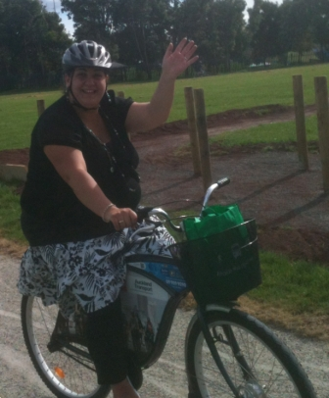
Nga Iwi story – Danielle Battista
Danielle Battista is both a parent and teacher aide at Nga Iwi School. When the Bikes in Schools project concept came to Nga Iwi, she supported it wholeheartedly as she believed there would be many benefits. As a parent, she also got involved. NextBike’s Jullian Hulls loaned bikes to Danielle and other parents for the school holidays, which proved to be a very positive experience for Danielle and her family. Along with the kids on their bikes the spent the holidays bike riding, especially to Mangere Bridge were there are good off-road cycle paths. An observation by Danielle is that there are now more children and adults cycling in Mangere and she believes that this is partly due to the Nga Iwi cycling project. As a teacher aide she believes the bikes in schools project has been incredibly uplifting for both the students and teachers. She strongly believes that many students now have more confidence in the classroom following on from the confidence gained by learning to ride a bike properly. For example, some children are now much more confident in presenting their shared news to their class and Danielle also believes that students are healthier. Another benefit, according to Danielle, is that the project has been very positive for the Image of Nga Iwi School and the wider Mangere community, when there had previously been some negative views of this area. The school community is very proud that their school has bikes and a track. Looking forwards, Danielle believes it will be important that the tracks and bikes are well maintained, partly because other schools will be looking to Nga Iwi as they plan their own cycling initiatives.

Cycle counts and bike rack counts
To determine the longer-term impacts of this project, cycle activity information was collected at local schools and in the Mangere community prior to the cycling project being implemented.

Cycle Counts
The cycle count results showed low levels of cyclists at all three intersections, averaging 14 adult and 14 child cyclists at each of the three intersections per weekday (Table 3). Numbers reduced further on the weekend to an average of 11 adults and 5 child cyclists per weekend day. Only 2.5% of child cyclists chose to ride on the road, with the remainder chose to ride on the footpath. This could indicate that child cyclists do not feel safe on the road when passing through the intersections surveyed.
Table 3. Average counts from cycle count surveys, carried out prior to the project commencement.
 | Weekday |  |  | Weekend
Mascot/Fresian | Road | Path | Total | Road | Path | Total
Adult | 4 | 7 | 11 | 4 | 6 | 10
Child | 1 | 23 | 24 | 0 | 10 | 10
Massey/Mascot | Road | Path | Total | Road | Path | Total
Adult | 9 | 7 | 16 | 4 | 11 | 15
Child | 0 | 1 | 1 | 0 | 4 | 4
Bader/Mascot | Road | Path | Total | Road | Path | Total
Adult | 7 | 10 | 16 | 3 | 6 | 9
Child | 0 | 15 | 15 | 0 | 2 | 2
Total Adult |  |  | 42 |  |  | 34
Total Child |  |  | 40 |  |  | 16

Low levels of cycling in Mangere could be due to a number of reasons. The Auckland Transport Travel Wise survey conducted in Term 2, 2011 identified road safety concerns as the main reason why Nga Iwi School parents do not allow their children to ride to and from school traffic. Volume, speed and lack of safe crossing points in the area were all raised as reasons why they choose alternative modes to transport their children to school. Also, although cycling is generally low in Auckland in general, the high social deprivation of a community such as Mangere, may mean that access to a bike is limited.

School Bike Rack Counts
Surveys of school bike racks were completed at four schools in Mangere over three days to determine the number of students cycling to and from school:

 | 29/11/2011 | 30/11/2011 | 1/12/2011 | average
Nga Iwi Primary | 0 | 0 | 0 | 0
Mangere Central | 1 | 2 | 0 | 1
Jean Batten School | 0 | 0 | 0 | 0
Sir Douglas Bader Intermediate | 4 | 2 | 2 | 3
The survey showed very low bike counts at all four schools with no bikes surveyed at Nga Iwi or Jean Batten School. Bikes were surveyed at both Sir Douglas Bader and Mangere Central. This could be due to these two schools catering for Year 7 & 8 students whereas Nga Iwi and Jean Batten Schools only cater up to Year 6.
The low bike rack numbers indicate that cycling to and from school is not a popular option for travelling to school in the area. Apart from the reasons given earlier, safe and attractive cycle routes to school and not having the skills to ride confidently on the road may also be reasons why cycling levels are so low in Mangere.

Pre-Training Surveys
Key results from the pre-training surveys were as follows:
- 43% of students surveyed do not own, or have access to a bike.
- 50% of students surveyed hardly ever ride or have never ridden a bike.
- 96% of students surveyed said they never ride their bike to school but often ride for recreational purposes (around local surroundings, in parks etc).
- The main reason for students not riding to school was not having access to a bike and secondly because parents won’t allow them to ride to school.
These statistics support the cycle count surveys and focus group discussions which indicate that levels of cycling are low and that owning a bike is not affordable for many families. Therefore, without a bike, several students have not been given the opportunity to learn. Those that did own a bike, mostly used it for very localised recreational purposes and restrictions on riding to school due to safety concerns prevents school cycle commuting. A full summary of these results is included in Appendix C.
Nga Iwi story – Patrick Nofoakifolau
Patrick Nofoakifolau works with the Mangere Neighbourhood Policing team. He was looking for an avenue to raise awareness of cycle safety and specifically wearing cycle helmets in his community. His opportunity came when he linked up with Auckland Transport who was planning the Bikes in Schools project for Nga Iwi School - correctly using and maintaining bikes and correctly fitting cycle helmets are key components of the project. Following the implementation of the Bikes in Schools project he sees more cyclists wearing helmets, and on questioning some of them, he has learned that students from other schools have learned about the benefits of cycle helmets from the Nga Iwi School project.
Patrick and his wife also loaned bikes from NextBike for use over the school holidays when the project started and they rode everywhere. This was to result in a longer-term commitment to physical activity (including purchasing their own bikes) and he and his wife have lost 23 kg and 20 kg respectively. He reports that they both feel much better, have more energy and this has been great for their family.
Encouraging his colleagues at NZ Police to use bikes for community policing, has also been important to Patrick, as they are cheap (compared with a patrol car), effective in local environments and a great way for NZ Police to connect with the local community, but he acknowledges that this may take longer to happen than he would like. However, from a community policing perspective, one important change that Patrick has already seen since the Bikes in Schools project was implemented, is less truancy, especially on days when students know they will using the bikes and track at school. It seems that going to school and using the bikes and track is a more attractive option than missing school for many potential truants.
An important consideration for the Nga Iwi Bikes in Schools project, Patrick believes, is the longer-term ownership of the initiative by Nga Iwi School and the Mangere community. He hopes that the benefits of the project will be obvious enough that there will be a natural demand to sustain the bikes, track and training over time.

Specific considerations & recommendations
Following the evaluation activities, the following considerations and recommendations are presented:

The implementation process
- Consideration: Good communication between the multiple parties involved was paramount to the success of this project. Good co-ordination through on-going communication has shown this project saved on costs. E.g. coordinating the construction of the main bike track and pump/skills track to be built at the same time saved on machinery costs. However, clear roles and responsibilities at the project outset may have assisted the project implementation.
Recommendation: Establish and maintain good communication between all parties involved and establish clear roles and responsibilities.
- Consideration: Identifying the costs to implement the project and determining who will fund the project needs to be established at an early stage. External funding was a vital part in the success of this project.
Recommendation: Establishing links with charities, trusts and local businesses capable of providing financial assistance or sponsorship will provide the project with a solid foundation for moving forward. Establish responsibilities for funding very early on.
- Consideration: No documentation of the track design was recorded from the earlier projects in Hawke’s Bay. Verbal design guidance was given by Bike On and a guide to building school bike tracks was eventually established.
Recommendation: Ensure that the track design and specifications (materials used, quantities etc) are well documented for future reference, building on the document that has already been produced.
- Consideration: The bikes track were considered to be well built, however concerns were raised over the spacing of the pump track mounds being too close together.
Recommendation: Evaluate the design used for the pump track and consider amendments based on the bike’s dimensions.
- Consideration: Construction was carefully coordinated over the summer school holidays which resulted in minimal disruption and reduced risk of hazards to students.
Recommendation: Consider construction over summer school holidays to minimise disruption to school activities.
- Consideration: A number of teachers missed out on the ‘train the trainer’ workshop provided at the school.
Recommendation: To ensure longer-term success, it is essential that teachers are taught the necessary skills to continuing teaching bike skills to students, but also to be champions for cycling at Nga Iwi school.
- Consideration: Teachers raised concerns that they were unable to supervise the entire bike track facilities on their own and required more support.
Recommendation: School to assign two or more teachers to supervise the bike track.
- Consideration/Recommendation: Where funding fell short with the school only able to purchase 30 bikes instead of 60 bikes, it was important to prioritise where available funds should be spent. In this case, the seniors were prioritised to receive bikes and training to establish a benchmark for cycle training within the school. With Year 6 in their final year at Nga Iwi School, they will take the skills and experiences learnt from the project to their new school.
- Consideration: Several students did not own a pair of appropriate footwear required for bike riding. This highlighted some of the very practical challenges of this project.
Recommendation: Schools can apply to various charities for funding of shoes if required.

Project outcomes
The following considerations and recommendations were made following the actual and potential outcomes of the project and looking forward to the future.
- Consideration: The cycle training proved to be a vital tool in the success of the project. Pre-cycle training surveys showed 50% of students either did not have access to a bike and/or did not know how to ride a bike prior to project implementation. All three focus groups mentioned how much information they had learnt from the training courses and workshops attended and indicated they were interested in learning/teaching their students to ride on the road. Grade 2 Cycle Training provides the basic skills for road riding.
Consideration: The project focusses on providing all children with the opportunity to learn how to ride and develop bike skills. By up-skilling children to on-road training, they may progress to school commuting. The majority of children interviewed within the focus group suggested they would like to ride to and from school, however, there are several constraints which prevent them from doing so, the most significant being concerns about road safety. Many necessary improvements outside the control of the school will ultimately dictate whether children can ride to and from school or not. For example, road safety improvements, reducing traffic volumes and speeds, improving or installing cycle lanes (including separated paths) and educating drivers are all likely to make cycling to school in Mangere a more realistic proposition. To encourage a shift towards increased cycling, the school, with the appropriate partnerships, can play it’s part by providing students with the appropriate training for cycling to school.
Recommendation: Establish a cycle training programme within the school which provides more advanced on-road training for Year 5 & 6 pupils. Establish on-going cycle training and maintenance workshops for parents and teachers, which could be made available to the wider community. Work with Auckland Transport to create safer local cycling environments.
- Consideration: Safety concerns were raised over the pump track being too overcrowded and students were often seen riding the pump track in the wrong direction.
Recommendation: Consider installing signs and or well enforced procedures indicating the direction of travel numbers allowed on the track.
Consideration: The school underestimated the number of training wheels required and needed to order more.
Recommendation: Determine from pre-training surveys how many students are capable of riding a bike without training wheels to determine quantities required.
- Consideration: Parents and teachers raised concerns over who will maintain the bike track and equipment and who will pay for the cost of maintenance. A consideration for the school is the longer-term maintenance budget required for the track as well as where will the funds will come from to maintain the bikes to a high safety standard.
Recommendation: Prepare a maintenance plan for the bike track, bikes and equipment and establish an annual budget for maintaining the facilities and equipment.
- Consideration: The project has created a positive buzz within the Nga Iwi community and it is important to maintain the momentum of interest amongst students and parents. On-going publicity of the bike track and its benefits could help to keep students and parents interested long term.
Recommendation: Ideas for promotion include regular marketing of the bike track in school newsletters providing regular updates on how the students are progressing. Establish a webpage on the schools website dedicated to the bike track where updates and photos can be posted. Organise a series of cycle events throughout the year to encourage support from parents and the wider community. Align activities with BikeWise, and BikeWise month etc.
- Consideration: Teachers and parents raised some suggestions to encourage more cycling within the wider Mangere community including setting up a cycling club in the community, campaigning for a cycle shop to open in the Mangere town centre and setting up an affordable bike hire system for families unable to afford the cost of purchasing bikes. The Nga Iwi track could possibly be used in weekends and after school hours with suitable arrangements.

Longer-term considerations – more people cycling in Mangere more often?
The cycling participation baseline measures that have been collected as part of this evaluation should be used as part of a longer-term evaluation of cycling participation in Mangere. The Nga Iwi Bikes in Schools project represents a good start in sparking culture of cycling in Mangere, however, it is clear that in order for this goal to be realised there are a number of further areas that need to be addressed in order to successfully lever off this initiative. Future cycling in Mangere could take the form of school and workplace commuting, recreational cycling, utility cycling (e.g. to shops and other short trips) or sport cycling. These different types of cycling have different requirements, which will need to be met, in order to increase numbers in the different areas.
Figure 11 shows how enablers might help to lever off the benefits of start-up initiatives like the Nga Iwi Bikes in Schools project.

Enablers
Longer term outcomes
Current Situation
Figure 11 – How the Nga Iwi Bikes in Schools project might eventually result in more people cycling in Mangere
The Nga Iwi Bikes in Schools project
- Using cycle track
- Cycle training
- Using school bikes
On-road cycle training and experience
More people cycling for recreation, utility and sport in Mangere
Safe and user-friendly community cycling infrastructure for children and adults
Access to bikes
Sport cycling participation opportunities

Final comments
It is clear that the Nga Iwi Bikes in Schools project has been tremendously successful in terms of implementation and immediate perceived benefits by the school community. The aim of the Bike On Bikes in Schools programme is to “encourage primary school pupils to become more active and healthy, help them develop various bike skills, build their self-esteem and confidence”, and by this measure, it would appear that the Nga Iwi project has achieved its aim.
Whether the project goes on to fulfil its ultimate goal of more people cycling in Mangere more often remains to be seen. The Nga Iwi Bikes in Schools has been a real spark for a culture of cycling in Mangere, but by itself it is not a solution. It will be critical that the owners of the ‘enablers’ that have been outlined earlier, play their part to lever off this very worthy initiative, to eventually create a true culture of cycling in Mangere.

Appendix A – Full Activity Diary from Auckland Transport Project Manager, Rebecca Hayden

Activity Diary Nga Iwi – Rebecca Hayden

Date | Achievement or issue? | Description including actions to address issues if appropriate
Mar 2011 | Achievement | - Kitch and Claire spoke to Nga Iwi School about the prospect of them being the first Auckland school to get a cycle track – the school agreed  - Kitch spoke to John Filmore (of John Fillmore Construction - JFC) who agreed to build the cycle track for free at Nga Iwi once we had approval from the Ministry of Education to do so.
July 2011 | Achievement | - Appointment of south walking and cycling co-ordinator who will project manage the cycle track project
July 2011 | Achievement / issue | - Rebecca makes contact with Paul McArdle who is keen to support  - Paul does not have track plans as all was done as it was built  - Paul and Rebecca have discussed that there is a need for documentation of all of this kind of thing.
August 2011 | Achievement | - Project plan for Mangere Community Cycling Project complete
August 2011 | Issue | - Storage for the bikes is an issue. There are no storage containers available and the cost of a custom built garage is prohibitive, especially as a building consent will be needed. The school may need to apply for more funding for this.
August 2011 | Achievement | - The school finds that they have an old garage already on site which is storing furniture. They have funding to build new storage for that furniture so they will use this for the bikes.
Oct 2011 | Achievement | - Project plan was signed off by MoE on the condition that the school hire their own MoE approved project manager to manage the actual construction onsite  - Project Manager – David Bowes appoint by school
Oct/Nov 2011 | Achievement | - The school gets its funding application for bikes and helmets into the Lion Foundation
Nov 2011 | Achievement | - Agreement with John Filmore to build the main cycle track at Nga Iwi school  - John may be able to get the track built over the school holidays
Nov 2011 | Issue | - John can’t fund the limestone so we need to find this or funding for this.  - Need to find a friendly free/cheap pump track designer then John Filmore will move some of his fill over to create the pump track  - The skills track at another school in central Auckland has kids falling off it due to the design of it (anecdotal report )  - Rebecca will suggest to the school that they apply for funding to get the Kennett brothers (or similar) to design and build the skills and pump tracks. This will cost approximately $10,000+.
Nov 2011 | Achievement/  Issue | - Meeting with Haydn and Mark from Woodhill Mountain Bike Park to discuss being involved in building the pump and skills track. Keen to support this project but not in a position to build the tracks for free. Would need to have some funding in the vicinity of $8,000-10,000 in order to build the two tracks.  - Need to find $10,000 for the pump and skills tracks  - Meeting arranged on site before the end of term 4 with key stake holders.  - Before meeting the following things need to happen:  - John needs bird’s eye view of GIS of a school cycle track in Hawkes Bay  - Figure out access for a Bobcat onsite  - Find out if a pump track can be designed ASAP  - Clarify the role of the project manager  - John offered that he may be able to find an independent project manager who may be able to do the role for free if that fitted with the needs and requirements of the school
Nov 2011 | Achievement | - Brief video descriptions of the tracks have been loaded onto the bikesinschools website. These have been useful.
Nov 2011 | Achievement | - Meeting with the school to fill them in and to discuss access for a Bobcat  - Contact made with Haydn Shore at Woodhill Bike Park regarding possible participation with being involved in the creation of a pump track at Nga Iwi school
Nov 2011 | Issue | - Rebecca trying to get John Filmore a birds eye view of the tracks in the schools in Hawkes Bay.  - Paul doesn’t have any plans for the tracks.  - Paul and Rebecca discussed again the need for documentation of all of this kind of thing and agreed to do this at the end of the project
Nov 2011 | Achievement | - Bike On NZ bike track descriptions written and passed on to John and BikeParks
Dec 2011 | Achievement/  Issues | - Meeting at school with key stakeholders  - Notes/Action points  - David clarified that his role (Project Manager) in this instance is to ensure that the Ministry of Education and Nga Iwi School’s best interests are met, that health and safety protocols are adhered to and he will make regular site visits.  - It was agreed that construction of the main track would take place during the 2011-2012 summer school holidays  - John can build the track but cant fund the limestone. Rebecca to investigate finding funding the limestone  - The Mayor has agreed to attend on the only day and time he is available – 1st March 2012 at 9am.  - Rebecca to hold parent group meeting next week  - Rebecca to continue to liaise with the Woodhill team and  potential funding avenues
Dec 2011 | Achievement | - John Filmore to build the main track over the summer.  - Hopefully Woodhill Park folk can build pump and skills track at the same time to cut down on costs (with Johns bobcat and equipment being on site already)
Dec 2011 | Issue | - Correspondence with Counties Manukau Sport to ask for assistance in funding with the pump and skills track
Dec 2011 | Achievement | - Verbal agreement for some CMSport/SPARC funding to support the Woodhill guys to build the pump and skills track over the summer at the same time as John Fillmore builds the main track.  - This funding should also be able to cover the cost of the limestone if need be.  - CMSport will be in touch tomorrow and Rebecca will meet with them next week.
Dec 2011 | Achievement | - Application for Lion Foundation funding for 30 bikes and helmets for the school to keep onsite is successful – granted $7,800  - Funding from CMSport for the pump and skills tracked all signed off - $10,000  - Winstone Aggregates agree to provide the limestone for free. Barb Cuthbert from Cycle Action Auckland asked her contact the GM of Winstones – value = Approx $2,200.
Jan 2012 | Achievement | - Building of the tracks begins after the Christmas/New Year break  - Photos taken of various stages of the track build process  - Tracks completed just before the start of term 1
Jan 2012 | Issue | - All limestone provided was used on main track. Mis-communication regarding getting more limestone and cost too prohibitive to get more.  - Red rock is used on the pump and skills track as it is purported to pack down well and is easier and cheaper to access than limestone
Feb 2012 | Achievement | - Bike building workshop with about 15+ parents to get 30 bikes built ready for the track opening. Nick Foster from Adventure Brands (where the bikes were from) ran the workshop.  - The Lion Foundation had their grants person (Johnny Gritt) there to get some good photos and do a story on it.
Mar 2012 | Achievement | - Opening ceremony , followed by cycle fun day for the whole school – only year 5 and 6s got to go on track but the whole school, including year 0s get to take part in cycle related activities
March 2012 | Issue | - The red rock is too thick and the bikes can’t pass over it very well. The wheels are getting stuck.
March 2012 | Achievement | - Some red rock has been removed and is now packing down really well. It should be fine to keep it and not replace with limestone
April 2012 | Achievement | - Auckland Transport has loaned 6 bikes to parents at Nga Iwi School – in time for the school holidays in the hope they would ride with their kids over the holidays
April 2012 | Achievement | - The track coach starts working at the school in the 2nd week of term and will work a couple hours a day for a few weeks which each class.
Apr-May 2012 | Achievement | - Woodhill Mountain Bike Parks doing intensive track and bike coach training at the school for kids and teachers – aim is that the teachers can take the knowledge and run activities in class time with the students
May 2012 | Achievement | - Focus groups conducted with 1 x group of parents, 1 x group of teachers, 1 x group of students for the evaluation of the project (Full report due in July 2012)

Appendix B – Focus group questions

Parent and teacher focus group questions for Nga Iwi cycling project

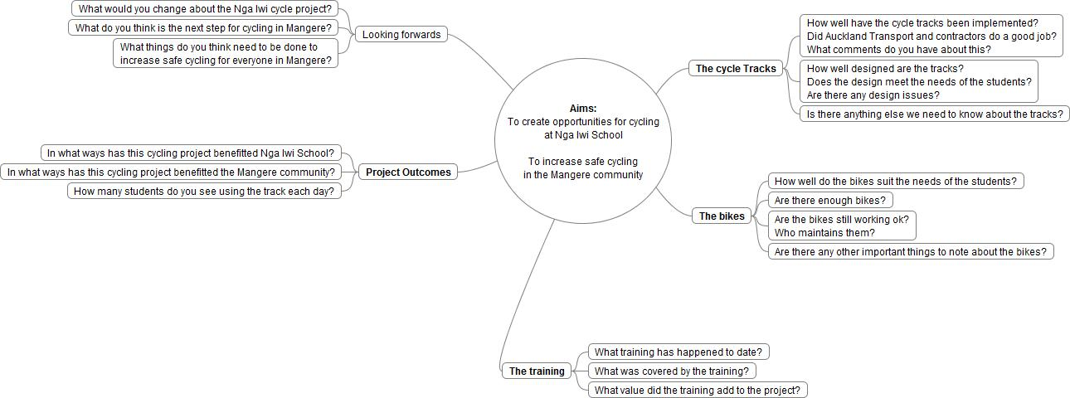

Student focus group questions for Nga Iwi cycling project

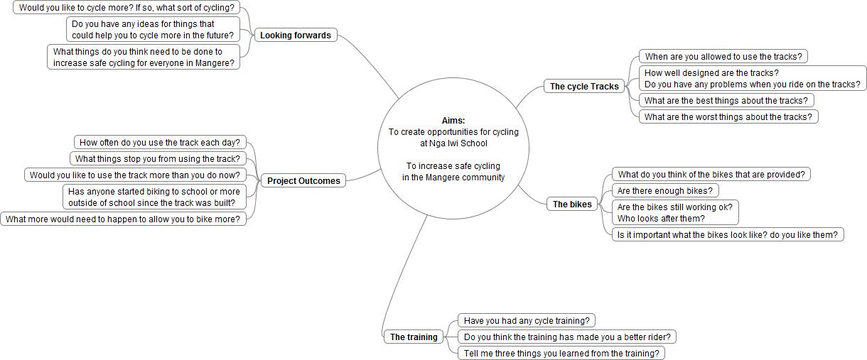

Appendix C – Pre cycle training survey data

